MUHAMMAD UMAR BAKHTIAR KHAN

STUDENT ID : L39519848

ASSESSMENT 2 REPORT

BLOCK NUMBER 6

BACK-END DEVELOPMENT

GitHub link to this project

* [Marvenomous/Rishton-Academy-Primary-School (github.com)](https://github.com/Marvenomous/Rishton-Academy-Primary-School)

GitHub link for the website

* [Marvenomous/Rishton-Academy-Primary-School (github.com)](https://github.com/Marvenomous/Rishton-Academy-Primary-School)

Contents

Introduction………..……………………………………………………………. 4

Document your website……..………………………………………………. 4

Reflect on your website………………………………..…………………… 14

Conclusion………………….…………………………………………………. 15

References……………………….……………………………………………. 16

**Introduction**

It all started at Rishton Academy Primary School with the objective of creating a digital school management database which can help store the primary school data digitally instead of having to rely on paper writing. There were some conditions to keep in mind, with the likes of one teacher having to teach only one class, to only one pupil being in a specific class while also keeping Reception Year, Year Two, Year Three, Year Four, Year Five, Year Six, Year Seven and the requirements of entities like teachers, students, classes, parents being necessary. There has been an addition of an enrollment section along with the login form to keep the database secure and robust with limited access only to those who require it, e.g. the administrator. With the help of Amazon Web Service (AWS) to launch an Instance to be able to run the Back end and upload the PHP files, there has been immense use of PHP, CSS and a good amount of JavaScript, making the website functional for its purpose. Mainly the technology that was used to make the database system was PHP/MySQL and the PHPMYADMIN was the source to save the database.

**Document your website**

With the focus in mind the front end of the website was worked upon to make it more presentable including sections of Home, About, Services and Login as Illustrated in Figure 1 below.

Figure 1 (The main page of the website for Rishton Academy Primary School)

There have been links embedded in the Home, About, Services and Login section on the footer to be able to navigate easily even if its not pressed on the navigation bar. The same is true for the other sections as shown in the illustrations below.

Figure 2 (About section of the Rishton Academy Primary School website)

Figure 3 (Services section of the Rishton Academy Primary School website)

Coming to the main element of the website is the Login page where the database can be looked at with secure login and further log out options when logged into the Admin Dashboard.

Figure 4 (Login page of the Rishton Academy Primary School website)

Further leading towards the login, the option of multiple databases arrive through which immense care was taken to link elements according to the ER diagram which has been shown in the illustration and how the Primary and Foreign keys are linked are also shown ahead.

Figure 5 (ER Diagram of the school management system)

Figure 6 (The Rishon Academy Dashboard)

Figure 7 (The code used to create an entity relationship between Parent and Student)

Figure 8 (The Students database showing Student ID and Parent ID being linked)

Of course, keeping in mind that there can be mistakes made when inputting data, focus was put on deleting or updating the database data to ensure efficiency and fast input of data without having to start all over as opposed to the paper system.

Figure 9 (The option to delete Student)

Figure 10 (Option to Update Student)

Care was also taken to include validation of form by making sure that only the right information is input in the specified fields for instance the inclusion of select tag with the required command on options like gender, class capacity option and it won’t proceed ahead unless the required fields are filled.

Figure 11 (The use of input type email)

The same applies for other sections like Parents, Enrollments, and even the Assistant Teachers making sure validation is of utmost importance to avoid any kind of bogus information along with any human error when inputting information in the specified fields.

Figure 12 (The option of adding teacher with validation of gender)

Figure 13 (Option to delete Enrollments)

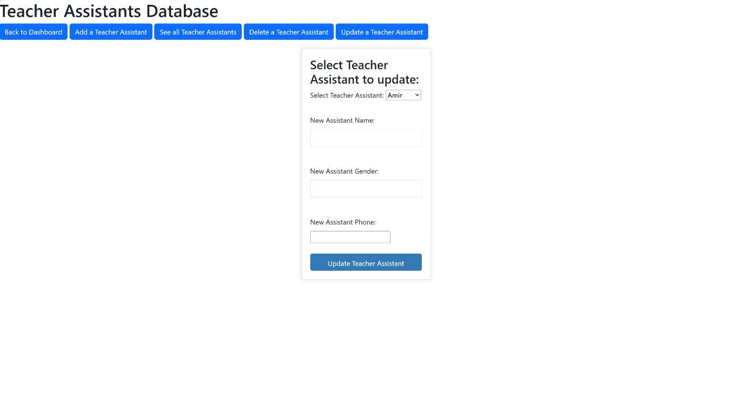

Figure 14 (The option to update Teacher Assistant)

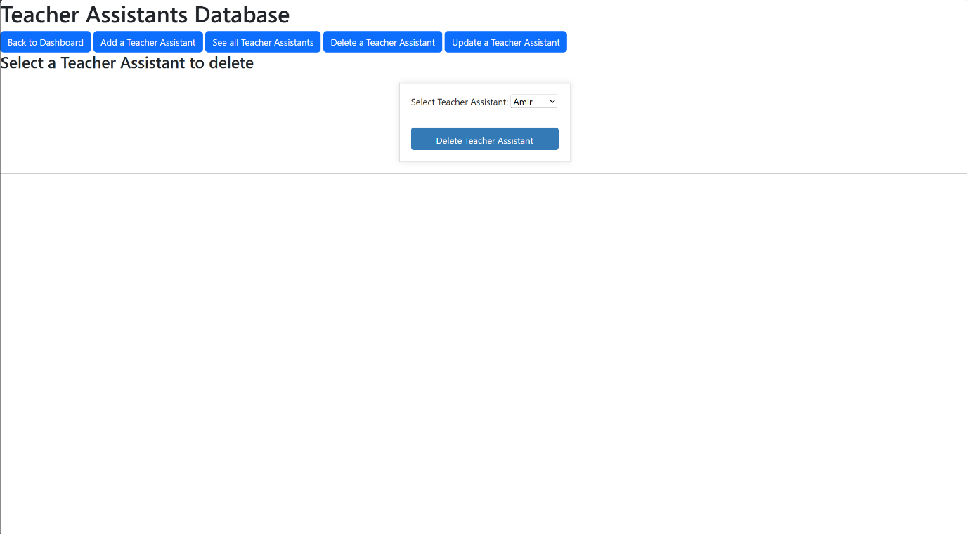

Figure 15 (The option to delete Teacher Assistant)

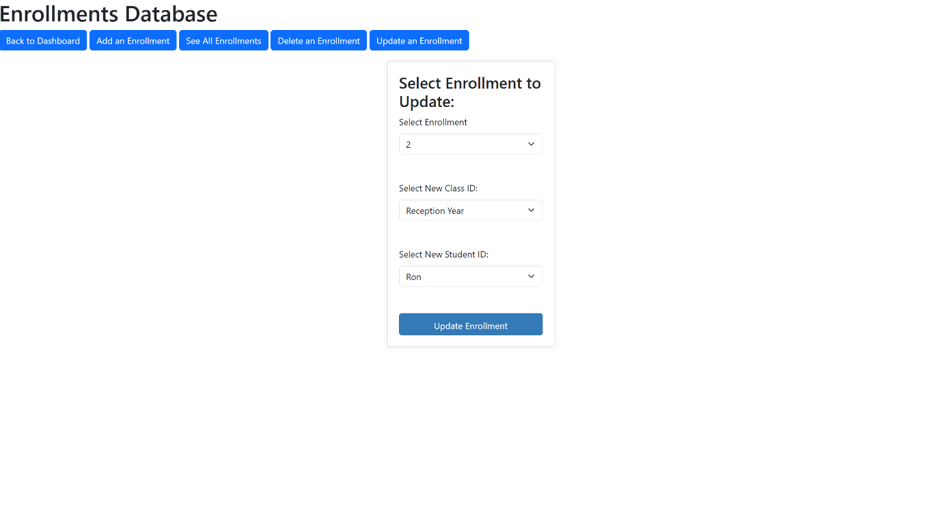

Figure 16 (The option to update Enrollments)

Figure 17 (Validation of Gender when adding Teacher)

Figure 18 (The Designer option of database in PHPMYADMIN showing the ER Diagram)

**Reflect on your website**

The option to use applications like XAMPP were indulging, however sticking with the idea of using AWS EC2 Instance was a better move due to the reason the AWS EC2 is market leading and innovative due to having to access PHPMYADMIN and the database online instead of having to rely upon a separate application, plus the transition of cloud storage is something to ponder over and it is taking over with blazing speed. Moreover, the use of MySQL seemed to have been a better decision due to it being an open source with multiple improvements expected over time as everyone contributes to the project. Not only that but it is cross platform, supporting pretty much any device or operating system which makes it more likely to be used and more versatile compared to Oracle or Microsoft SQL (ref: ChatGPT). Hence why the option of MySQL was generally preferred.

**Conclusion**

Back end can be considered quite important in this situation as without back end the use of front end is useless as in cases like these data has to be stored on a database system like PHPMYADMIN and retrieved when needed in the case of a system corruption it is still accessible on other devices without any kind of hassle. Moreover, the option of updating, adding or deleting the data at any time with easy accessibility is the main goal succeeding over here. Having to build over from a simple ER Diagram to all the way making a full-fledged management system has been one of the best accomplishments while learning something new overtime and better troubleshoot any kind of errors that occur on the way. Last but not the least the use of git to upload files to the GitHub was an experience of its own.

Figure 19 (Uploading files through Git to GitHub)

**References**

Form login: <https://www.youtube.com/watch?v=wODW8RLBPt0>

Front-End webpage: [GitHub - GNiruthian/Jaffna-College: Jaffna College](https://github.com/GNiruthian/Jaffna-College)